Irish & American Paediatric Society
The
Journal
of
ISSUE
JANUARY 2026
12
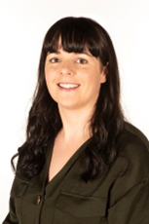
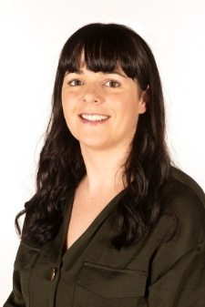
Make sure you save the date for our upcoming meeting in Cleveland on Tuesday September 15th to 18th September 2026. We are very grateful for all the work by Rita Ryan to secure some excellent keynote speakers including Prof Rachel Stanley Division Chief of Emergency Medicine from Ohio who will talk on resilience and joy in medicine, Prof Richard Martin, from Case Western Reserve University (CWRU) on Lessons Learned and Assoc Prof Nathan Stehouwer from CRWU on Clinical Decision Making. Abstract submission will open 12th February until 10th April 2026 so please prepare your abstract for submission and save the date.
Finally, I want to acknowledge all the hard work by our former executive director Regina Mirabella over the past 7 years and how grateful we all are for everything she did. I am thrilled to welcome Barbara Leyva from Stony Brook, who will bring a fresh perspective to the role of executive director.
I wish everyone good health and look forward to welcoming you to Cleveland in September 2026. Best wishes for 2026!
Sheena Durnin
Paediatric Emergency Medicine Consultant
Children’s Health Ireland, Dublin.
Dear Colleagues,
It is with great pleasure that I write this message to wish you a happy New Year. We had a great time having the 56th annual IAPS meeting in Dublin, Ireland in March. This was a great opportunity to meet up with friends and get introduced to new members. The Len and Arlean Fries Travel awards were given to three worthy winners who received travel grants to enable them to attend. Their submissions were to a very high standard, and they gave very interesting lectures. Colm Travers and his scientific committee worked hard to plan the scientific programme, and we were grateful for the kind donation of Willie O’Connor to assist a medical student to travel.
The keynote speakers including Prof Lise Johnson from Harvard on the power of newborn behavioural observations on neonatal care, an excellent update on Cystic Fibrosis from Prof. Basil Elnazir from Children’s Health Ireland in Dublin and a superb lecture by Prof. Patrick McNamara from Iowa on haemodynamics and its effects on the lungs in the neonatal period. The talks were all very well received.
Regina Mirabelle assisted by Lisa Clarke did an amazing job co-ordinating the conference in Dublin including a trip to Áras an Uachtaráin (Presidents House) thanks to connections from John McLoughlin and a guided a tour of the new National Children’s Hospital in Dublin. We attended live Irish music in Temple Bar which was really enjoyed. Several members attended the Irish Neonatal Society Meeting which got great feedback.
Membership
Drive

It’s that time to get in your 2026 membership dues which support the expenses for our conference and our society. Our 2026 membership fee ($100-quite a value) is due January 2026 for the calendar year to support the development of the US Conference activities and our society. Of course, tax deductible donations to our IAPS Foundation continue our mission of supporting our travel awardees to foster their scientific developments.
Photos from the IAPS conference in Dublin 2025
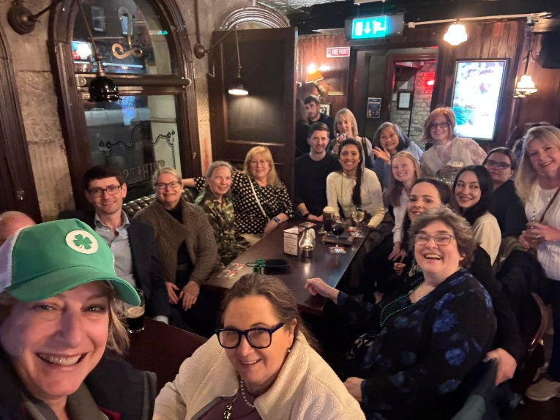
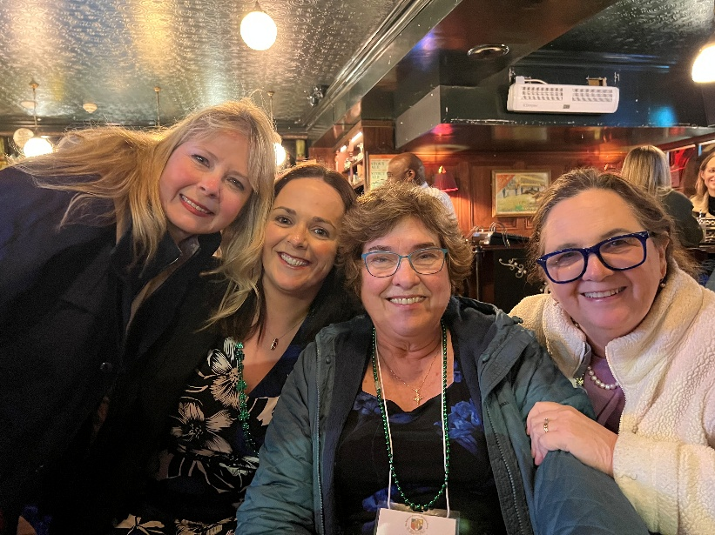
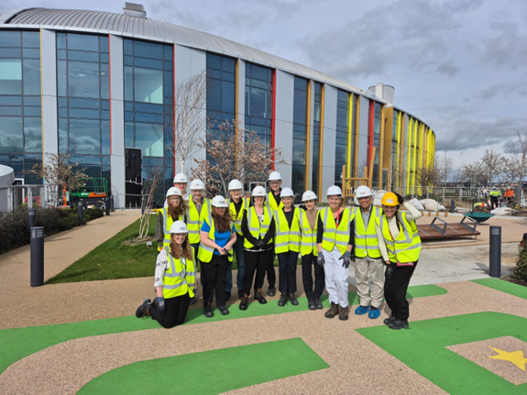
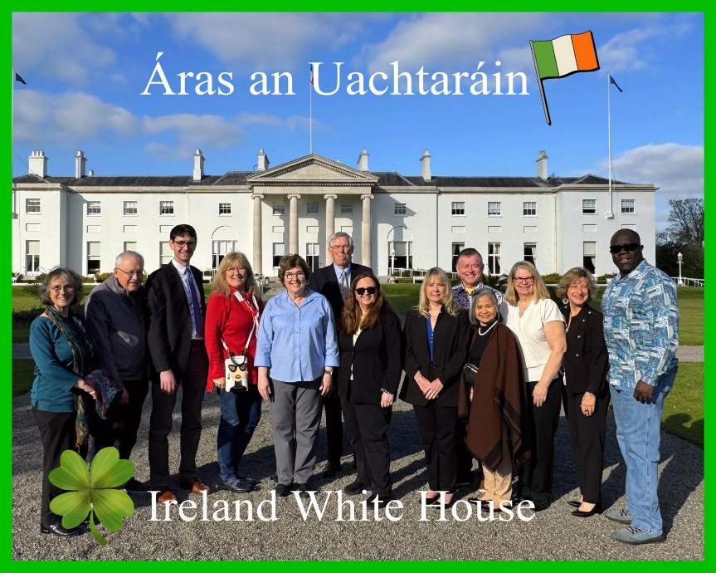
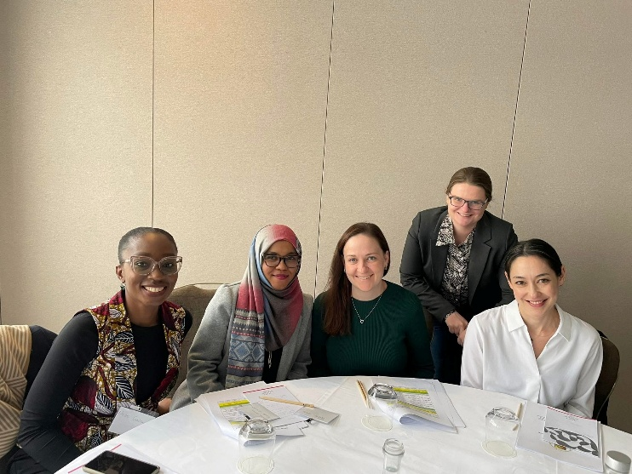
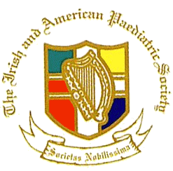
This Month’s Q&A Technology Tips

The Irish and American Paediatric Society, INC

The Irish and American Paediatrics Society Foundation
The Foundation, supported by member donations, is a federally recognized nonprofit organization.
Donations are tax-deductible. The purpose of the Foundation is to advance paediatric knowledge in Ireland and North America
and to share this knowledge.
The Foundation’s educational efforts are accomplished through:
The presentations of travel awards to the Irish and American Paediatric Society, Inc.
1. The presentations of travel awards to pediatricians in training in Ireland to come to North America/ and those in North America to come to Ireland to present their research.
2. Further educational and professional growth in areas of clinical, technical, scientific procedures, and research.

Awards are granted on a competitive basis, and winners are selected by committees in Ireland and North America. Recipients
are required to attend our annual meeting and present their papers.
A total of 4 travel awards will be awarded to resident doctors. In addition, there will be 1 travel award for a medical student and
1 for a student in the NP program. The winner is selected by the Scientific Committee, and those selected will be contacted via
email.
Abstracts can be submitted via email from February 12th, 2026, to April 10, 2026.
Please submit via email IrishAmericanpaediatricsociety@gmail.com

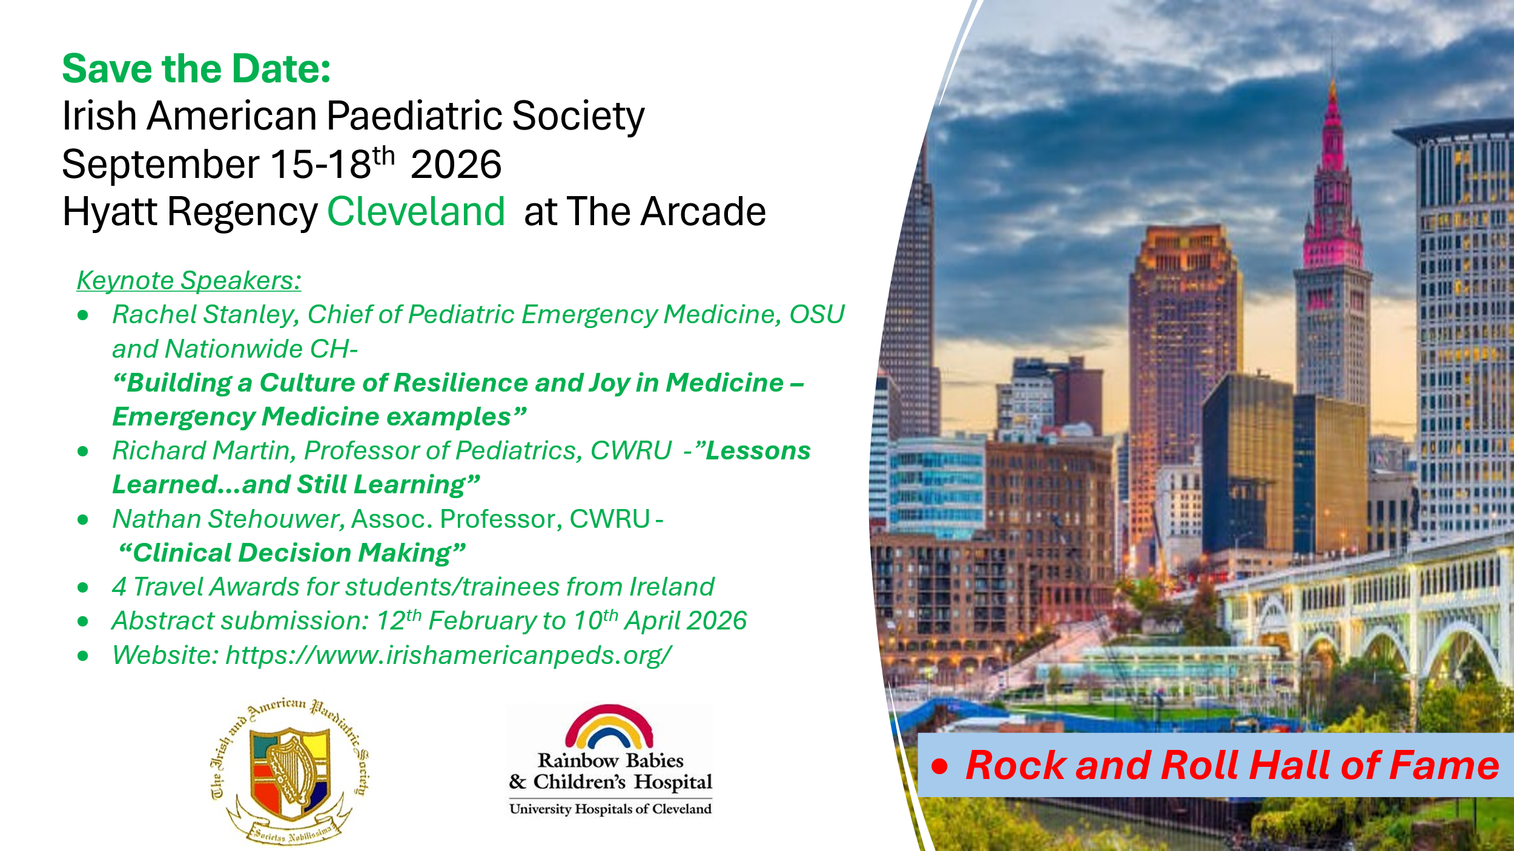

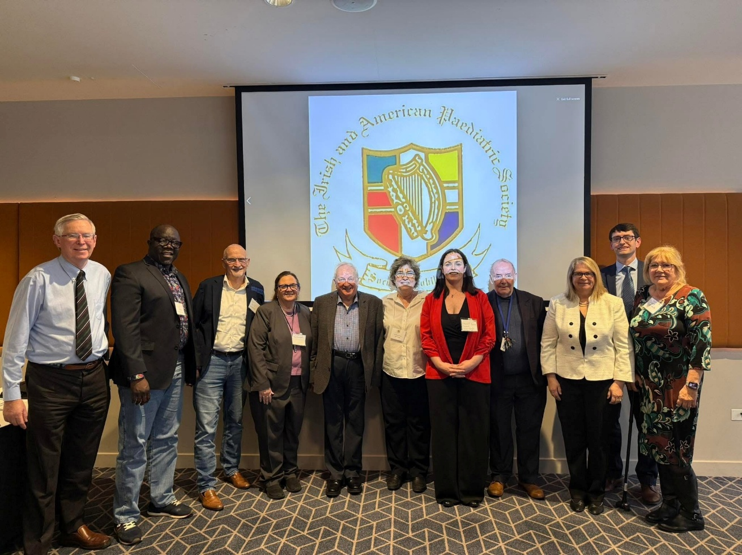
Meet the Council

President: Sheena Durnin, MD
Past President: F. John McLaughlin, MD
President Elect: Lisa Clark, MS, CPNP
Scientific Committee Chair: Colm Travers, MD
Rita Ryan, MD
Webmaster: Ward Rice, MD
Declan Quinn, MD
Marty Weisse, MD
Echezona Madueke, MD
Willie O’Connor, MD
Mariette Murphy, MD
Aoife Branagan, MD
Meredith Kinoshita, MD
Executive Director: Barbara Leyva, MSN, RNC

The Irish & American Paediatric Society 57th Annual Conference
September 15-18th, 2026
Hyatt Regency, Cleveland
420 Superior Ave, Cleveland, OH 44114, United States
Phone 00165751234

PLEASE RETURN REGISTRATION FORM WITH PAYMENT NO LATER THAN July 30th, 2026
Return form by email to: irishamericanpaediatricsociety@gmail.com
Payment via paypal thru Cleveland 2026 link (registration fee) @ https://www.irishamericanpeds.org/

Name______________________________________________________________________________

Address____________________________________________________________________________

Email Address_______________________________________ Phone __________________________

Affiliation___________________________________________________________________________

Guest Name (s) __________________________ Phone ______________________________________

REGISTRATION Fee (US Dollars) NUMBER TOTAL
Conference fee $500* ________ ______________
NCHD’s / Residents $350* ________ ______________
Medical students $350* ________ ______________
Guest fee $350* ________ ______________
* Includes welcome reception on Tuesday and 3 course meal on Wednesday

Please indicate if you will be attending events below by ticking box:
- Tuesday 15th September: Welcome Reception Dinner @ Hotel
6:00 pm Welcome Reception and Speaker @7:30 pm

- Wednesday 16th September: Scientific meeting day 1- 8 am to 4 pm @ Hotel
Lunch and coffee Breaks will be available for Registered Session Attendees
6:00 pm Presidents Reception (3-course dinner) and entertainment

- Thursday 17th September: Grand rounds & meeting at Rainbow Babies

- Thursday 17th September Afternoon: Rock & Roll Hall of Fame (purchase tickets online)

Please note any dietary needs or allergies Gluten free Vegetarian Halal Allergy __________________

Please register for accommodation directly with Hyatt Regency Cleveland at The Arcade
https://www.hyatt.com/events/en-US/group-booking/CLERC/G-IAPS

Room rate $210 US a night (plus taxes), including a $30 voucher for breakfast per person per night.

Please contact Barbara Levya at irishamericanpaediatricsociety@gmail.com with any questions.
631-839-8926 cell

Membership Fee Annual Dues (Jan-Dec) $100. See the next page for the form to join. Free for NCHD’s/residents

The Irish and American Paediatric Society, Inc.
Registration and Annual Dues Statement
You may complete this form, scan, and return as an attachment to the email address noted below
Annual Dues (Jan-Sep) $100.00 (After September, $125.00)
No Dues for Trainees. Circle here if Trainee

Member Name:
Degree(s)

Contact information:

Street address:

______________________________________________________________________________________________________home/work

City State Country Postal/Zip code

Phone Fax
Email: ________________________________________________________________personal/work

Spouse: ____________________________________________________________

Annual Dues……………………………………………………………... $___________

Foundation Contribution ………………………………………………... $___________

The Foundation supports the Arlean and Len Fries Travel Awards for residents, registrars and fellows (contributions are tax deductible; see reverse side). Please contribute $25.00 or more—if possible---to help fund the travel award program and its pediatric education goals. Your past support has been extremely generous and very much appreciated. Thank you.

TOTAL…………………………………………………………………… $______ ___

Dues may be paid online at PayPal
https://www.irishamericanpeds.org/
Any questions, please contact:
Barbara Leyva MSN, RN, RNC-MNN
32A Dryad Road
Rocky Point, NY 11778
Irishamericanpaediatricsociety@gmail.com
631-839-8926

Member News
We would like to congratulate Colm Travers and his wife on the birth of their son on November 19, 2025
We look forward to seeing you all in Cleveland, Ohio, in September 2026!!!

