The Irish & American Paediatric Society 56th Annual Conference
March 25-28, 2025
Hyatt Centric, The Liberties Dublin
Dean Street, Dublin, D08 W3X7 Ireland
Phone +353 1708 1999

PLEASE RETURN REGISTRATION FORM WITH PAYMENT NO LATER THAN February 21, 2025
Return form by email to: irishamericanpaediatricsociety@gmail.com
Payment via paypal thru Dublin 2025 link (registration fee) @ https://www.irishamericanpeds.org/

Name______________________________________________________________________________

Address____________________________________________________________________________

Email Address_______________________________________ Phone __________________________

Affiliation___________________________________________________________________________

Guest Name (s) __________________________ Phone ______________________________________

REGISTRATION Fee (US Dollars) NUMBER TOTAL
Conference fee $400* ________ ______________
NCHD’s / Residents $150‡ ________ ______________
Medical students $90‡ ________ ______________
Guest fee $200† ________ ______________
* Includes dinner on Tuesday and Wednesday
‡ Includes one evening meal so please specify below. Additional evening meal is $75
†For dinner only on Tuesday and Wednesday

Please indicate if you will be attending events below by ticking box:
- Tuesday 25th March: Presidents Reception Dinner @ Hotel
6:00 pm Presidents’ Dinner (3 course meal & wine included) and Speaker @7:30 pm

- Wednesday 26th March: Scientific meeting 8 am to 4 pm @ Hotel
Lunch and coffee Breaks will be available for Registered Session Attendees
Business meeting for IAPS council members to follow at 4:15 pm

- Wednesday 26th March: Closing Dinner @ Hotel @ 6:00 pm with speaker 7:30 pm

- Thursday 27th March: Spitafields - By Invite Only for IAPS Council members/Guests

Please note any dietary needs or allergies Gluten free Vegetarian Halal Allergy __________________

Please register for accommodation directly with Hyatt Centric The Liberties Dublin
Phone +353 1708 1999 https://www.hyatt.com/en-US/group-booking/DUBCT/G-UUU3
Room rate €215 a night with breakfast included.

Please contact Regina Mirabella at irishamericanpaediatricsociety@gmail.com with any questions.

Membership Fee Annual Fee Due 2025 (Jan-Dec) $100. See form below to join. Free for NCHD’s/residents

The Irish and American Paediatric Society, Inc.

2025 Membership Statement

Annual Dues (Jan-Dec) $100.00 (After September, $125.00)

Member Name:
Degree(s)

Contact information:

Street address: __________________________________________________________________________________________________________home/office

City State Country Zip code

Phone Fax

Email: ________________________________________________________________personal/office

Spouse: ____________________________________________________________

Annual Dues……………………………………………………………... $___________

Foundation Contribution ………………………………………………... $___________

The Foundation supports the Arlean and Len Fries Travel Awards for residents, registrars and fellows (contributions are tax deductible; see reverse side). Please contribute $25.00 or more—if possible---to help fund the travel award program and its pediatric education goals. Your past support has been extremely generous and very much appreciated. Thank you.

TOTAL…………………………………………………………………… $______ ___

https://www.irishamericanpeds.org/  under More tab Dues  Payments via PayPal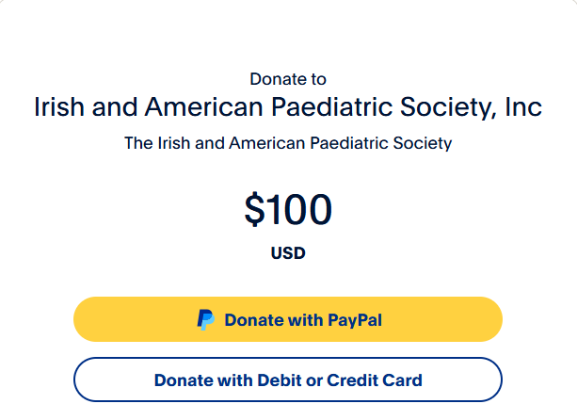 | checks payable to :  The Irish and American Paediatric Society  Mail check to: Regina Mirabella, Ed.D., MSN, RN  12860 Honeybrook Drive  Hudson, Fl 34669  Irishamericanpaediatricsociety@gmail.com  727-858-7711

